 | Sunil Nair
10/20/1966
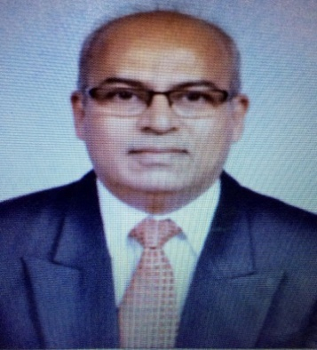 | 2B – 804, Kanishka,  The Great Eastern Links,  Ram Mandir Road, Goregaon (West)  Mumbai - 400 104  Maharashtra, India.  Cell: +919892290985  : +919167290680  sunil.sn@gmail.com
Synopsis
A Senior Corporate Professional and an entrepreneur with 30 years of experience having handled diversified portfolios including Sales, Marketing, Customer Care, After Market Sales, Support, Recruitment and Training. Sunil’s professional experience spans organisations like Hindustan Unilever, Marico Industries, Inchcape PLC (Oman), Kansai Nerolac, Saint Gobain and Mahindra & Mahindra.
Sunil has in depth exposure and working knowledge of FMCG, Paint & Hardware, Automobile Spares, Abrasives, IT and Healthcare. Sunil is an independent director on board with Quality Care Dialysis, a US based healthcare company that is into kidney care.

SKILLS
- P & L Management
- Marketing & Business Development
- Supply Chain & Vendor Management
- Creative Thinking& Visioning
- Strategic Planning & Change Management
- Training, Learning & Development
- Team Management
- Infrastructure Development & Management
- Methodology Development
- Strategic Partnerships
- Business Process Re-engineering

experience

QuantumLink Communications
2006- 2013
Industry: Information Technology
Role: As Vice President Sales with Profit Centre accountability, was responsible for driving business goals through goal setting, market mapping, product placement, pricing and promotions, manpower recruitment and training.

Mahindra & Mahindra
2003-2006
Industry: Automobile
Role: As Head of Sales for the INR 3000 crore business, was responsible for top line and bottom line growth, new business acquisition, dealer and vendor management along with training and development of the 450 team members. Business projections, manpower and infrastructure assessment and acquisition along with inventory and warehouse management were the key deliverables.

Saint Gobain Abrasives
2001- 2003
Industry: Engineering Goods
Role: As Head – Retail Marketing, key responsibilities included setting up Distribution Network, Creation and Implementation of Marketing Plans, New Product Launches, Recruitment & Retention, Production Planning

Regional Sales Manager | Kansai Nerolac Paints
2000 - 2001
Industry: Paint & Hardware
Role: Sales Management, Revenue Optimization, Supply Chain Management, Receivable Management, ERP Implementation, Training, Channel Management

Sales Manager – Van Operations | Matrah Cold Stores, An Inchcape PLC Associate (Oman)
1997 – 1999
Industry: FMCG Distribution
Role: Initiating & Implementing Van Distribution Network, Supply Chain Management, Vendor Management, Warehouse Management, New Product Launches, Automation & MIS

Asst Manager – Institutional Sales | Marico Industries
1997
Industry: FMCG
Role: Key Account Management, Government Supplies, New Product Launches, Product Approvals For Government Procurement

Sales Officer – Soaps & Detergents | Hindustan Unilever Ltd
1988 – 1996
Industry: FMCG
Role: Front Line Sales, Re Distribution Stockiest Management, Display & Merchandising, Rural Market Development, Executing Promotional Plans & New Product Launches.

- Education
- Ph.D. in Organizational Psychology
- Masters in Computer Application
- Bachelors in Physics

- PROFESSIONAL AWARDS
- MBA- Human Resource Management
- Post Graduate Diploma (PM & IR)
- Post Graduate Diploma (HRM)
- MBA – Marketing

